**Dear Variety Friends:**

**Yesterday, we celebrated the holiday season early in Wheeling, West Virginia!**

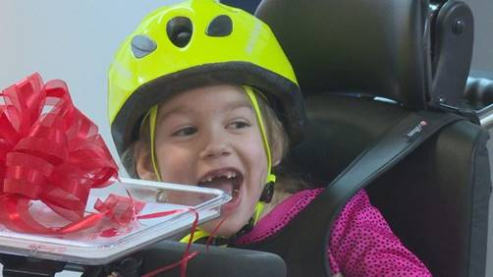

*Jordyn is pictured above ALL SMILES on her new bike (photo by WTRF).*

**Variety partnered with Southwestern Energy yesterday to host a special presentation for local kids in the Wheeling region to receive new adaptive equipment, and we were even joined by Wheeling Mayor Glenn Elliott!**

In total, Variety presented 4 adaptive bikes, 2 adaptive strollers, and 1 communication device, as well as fit 4 more kids for a bike or stroller (i.e. the last step before ordering equipment). Excitingly, two of the kids yesterday received multiple pieces of equipment, as **Variety does not put a limit on families receiving more than one piece of equipment**. If a child is eligible and can benefit, we want families to have it.

**It was a VERY special moment for parents Kathy and Vernon, as they watched their 8-year old boy, Levi receive his very own adaptive bike. It got even more special as Variety fit Levi’s twin sister, Emmalee for HER adaptive bike!**

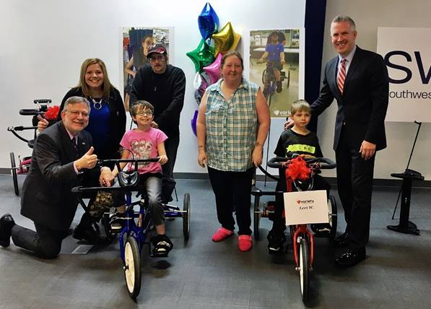

*Pictured above are Emmalee on a blue bike and Levi on his red bike with myself, Amy Dobkin (Southwestern Energy & Variety Board), Kathy and Vernon, and Mayor Elliott.*

**Here’s what Kathy shared with us during yesterday’s presentation,**

**“I have twins. This is Emmalee and this is Levi. They are both autistic, and even though Emmalee speaks, she can’t answer yes or no questions to let us know if she was hurt.**

**Before coming here today, I heard about Variety’s other programs, including their “My Voice” Program, and that’s big for us because we have never heard Levi talk, as he is nonverbal. Recently, Levi has started to verbalize sounds, which is huge for us.**

**And now for the first time, he’s going to be able to ride a bike after. It is going to give my child more freedom, which is huge!”**

Check out these two terrific pieces done by [**WTOV**](https://wtov9.com/news/local/organizations-provide-adaptive-bikes-to-kids-with-special-needs) and [**WTRF**](https://www.wtrf.com/community/charity-gives-local-children-with-disabilities-a-special-gift/1581677982) to experience the joy of yesterday for yourself!

Have a great weekend!

Charlie

**Charles P. LaVallee**

**Chief Executive Officer**

**Variety – the Children's Charity**

11279 Perry Highway, Suite 512

Wexford, PA 15090

Office: (724) 933-0460

Cell: (814) 431-9030

Fax: (724) 933-0466

[charlie@varietypittsburgh.org](mailto:charlie@varietypittsburgh.org)

[www.varietypittsburgh.org](http://www.varietypittsburgh.org/)

**United Way Code: 2195**

**Stay Connected:**[cid:image001.png@01D218BD.89940330](https://www.facebook.com/varietypittsburgh)  [cid:image003.jpg@01D21B32.F4C56E60](https://www.instagram.com/varietykids/)  [cid:image004.png@01D218BD.89940330](https://twitter.com/VarietyKids)  [cid:image005.png@01D218BD.89940330](https://www.youtube.com/user/varietytent1)

“Anyone who does anything to help a child in this life is a hero to me. ”   
― [Fred Rogers](http://www.goodreads.com/author/show/32106.Fred_Rogers)